P530/2
BIOLOGY
Paper 2
August, 2019
2½ Hrs
UNNASE


Community
UNNASE MOCK EXAMINATIONS

Uganda Advanced Certificate of Education
BIOLOGY
(Theory)
PAPER 2
2 Hours 30 Minutes

INSTRUCTIONS TO CANDIDATES:
- This paper consists of Sections A and B
- Answer question one in Section A plus three others from Section B
- Candidates are advised to read the questions carefully, organize their answers and present them precisely and logically, illustrating with well labeled diagrams wherever necessary.
- Begin each question on a fresh page.

SECTION A (40 MARKS)
- Figure 1 below shows the effect of increasing light intensity on the rate of release of oxygen by two woody plants, a sun plant and a shade plant. The sun plant is a tall tree while the ‟shade plant “grows on the woodland floor.
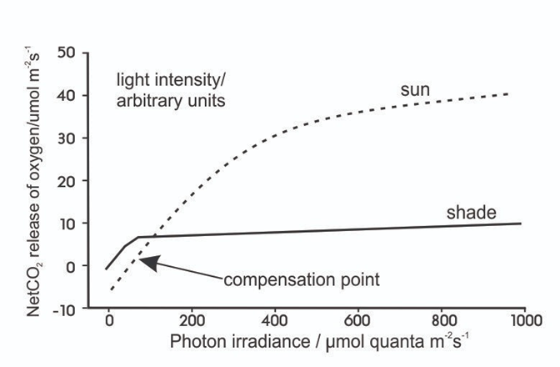
Figure 1

Net release of O₂/μmolm⁻²s⁻¹
Photonirradiance / μmolquanta m⁻²S⁻¹⁻

a) i) Compare the effect of increasing light intensity on the two plant types.
(08 marks)
ii) Explain the effect of increasing the light intensity on the sun plant. (07 marks)
iii) Suggest and explain the reason for the difference in the effect of increasing light intensity on the two plants. (08 marks)
b) Figure 2 below shows the effect of increasing temperature on the net assimilation rate of carbon dioxide by barley and maize plants. Barley was grown at different temperatures in ambient (normal atmospheric) and high levels of carbon dioxide. Maize were grown at different temperatures in ambient carbon dioxide
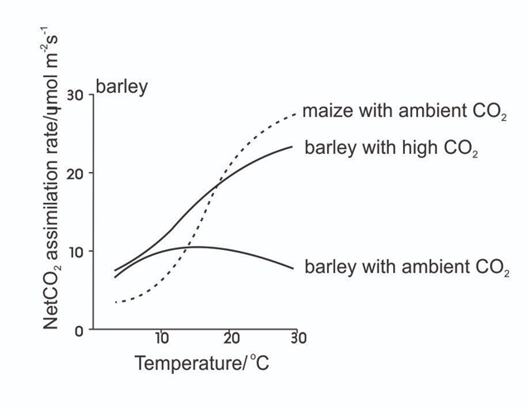
Figure 2
Net CO2 assimilation rate / μmol/m²S⁻¹

i) Explain the effect of increasing carbon dioxide concentration and temperature on the net carbon dioxide assimilation rate of barley. (05 marks)
ii) Explain the difference in the effect of increasing temperature on the uptake of carbon dioxide in maize at ambient carbon dioxide concentration compared with the effect concentration in Barley at ambient carbon dioxide. (05 marks)
iii) Use Figure 2 to suggest and explain why C4 plants tend to be found in hotter, more arid regions than C3 plants. (07 marks)

SECTION B (60 MARKS)

- a) Describe the physiological behaviour of the rods during; (14 marks)
- darkness
- low light intensity
- exceedingly high light intensity

b) Explain the significance of the compactness of cones at the fovea. (06 marks)

- a) Explain how the following are determined: (13 marks)
- ABO blood groups
- Sex in Man

b) Explain Charles Darwin’s finches in terms of evolution. (07 marks)

- a) Describe how the stratosphere is destroyed. (13 marks)

b) Outline the indicators to support the destruction of the stratosphere.
(03 marks)

c) What is meant by an indicator species? (04 marks)

- a) Describe the modifications of Munch’s theory of translocation. (05 marks)

b) Describe stomatal movement basing on mineral ion change theory.
(12 marks)
c) What are the evidences to reflect that active movement of sugars within the sieve tube is based on the activity of the companion cells? (03 marks)

- Describe the effects of light on:
- abundance,
- morphology,
of plants (20 marks)

⋆⋆⋆⋆END⋆⋆⋆⋆

